**DDL COMMANDS**

**Create command**

**Query:**

use Exp;

create table Workers

(S no int primary key,

Name char not null,

Designation char not null,

Branch char not null,

Phone number int unique,

Address char not null,

Years of experience int not null);

OUTPUT:

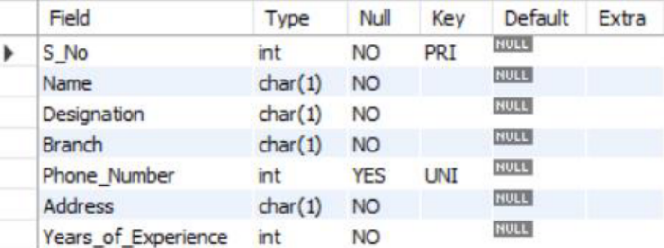

Alter Command

Query:

use exp;

alter table workers add

(Alternate_PNo int not null);

OUTPUT:

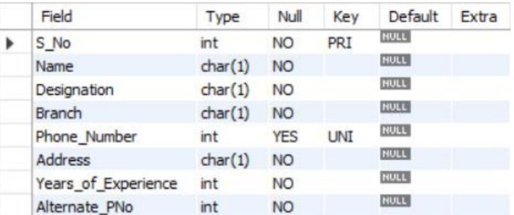

DROP COMMANDS

Query:

Use exp;

Drop table workers;

Output:



**TRUNCATE COMMAND**

**Query:**

use Exp;

truncate workers1;

Output:

